RADIOLAB Podcast “Henrietta’s Tumor” Homework Assignment

Name: __________________________________________

Listen to the amazing Radiolab Podcast “Henrietta’s Tumor” (Click on link to access podcast. You must have internet access to do this). On the same Radiolab webpage, below the podcast, is a 10 minute video called “Living Human Cells In Culture” where you can learn how cell cultures are prepared and see actual HeLa cells under magnification. Completely answer all questions below. Your grade will be based on how complete and correct your answers are.

- Who was Henrietta Lacks? (You will need to listen to the entire podcast before you will learn all of the information needed to completely answer this question.)

- Why did Henrietta seek medical attention at Johns Hopkins Hospital?

- Why were Henrietta’s cells of interest to tissue culture researchers? Which cells did they take from her body?

- Specifically what did Henrietta die of? How old was she when she died? (You will need to listen to the entire podcast before you will learn all of the information needed to completely answer this question.)

- Researchers took cell samples from Henrietta on two occasions. Describe.

- What is HeLa? What’s so special about these cells?

- Why have HeLa cells been important to research on polio and other medical conditions?

- What problem did HeLa cells eventually cause for cell biology researchers?

- When did Henrietta’s family learn of the importance of her cells? Did her family have a good understanding of what HeLa cells were and why are they important? Do you think the medical establishment did right by Henrietta’s family?

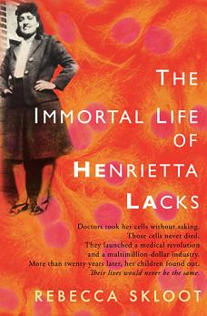
If you found this story interesting, you’ll love the NY Times bestselling book about Henrietta’s life and legacy, “The Immortal Life of Henrietta Lacks”, by Rebecca Skloot.

